IPV6 Simple Static Route LAB 20

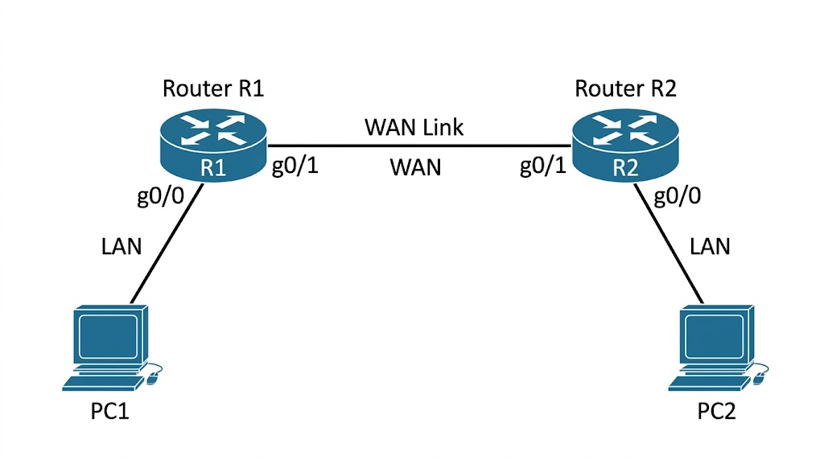
IPv6 Addressing :
- R1 LAN: 2001:db8:10::/64 (R1 is ::1, PC1 is ::10)
- R2 LAN: 2001:db8:20::/64 (R2 is ::1, PC2 is ::10)
- WAN Link: 2001:db8:12::/64 (R1 is ::1, R2 is ::2)

Router 1 Configuration
R1(config)# ipv6 unicast-routing
R1(config)# interface g0/0
R1(config-if)# ipv6 address 2001:db8:10::1/64
R1(config-if)# no shutdown
R1(config)# interface g0/1
R1(config-if)# ipv6 address 2001:db8:12::1/64
R1(config-if)# no shutdown

Router 2 Configuration

R2(config)# ipv6 unicast-routing
R2(config)# interface g0/0
R2(config-if)# ipv6 address 2001:db8:20::1/64
R2(config-if)# no shutdown
R2(config)# interface g0/1
R2(config-if)# ipv6 address 2001:db8:12::2/64
R2(config-if)# no shutdown

Routing configuration
R1
R1(config)# ipv6 route ::/0 2001:db8:12::2
R2
R2(config)# ipv6 route 2001:db8:10::/64 2001:db8:12::1

Verification
R1# show ipv6 route static
R1# ping 2001:db8:20::1 source g0/0

